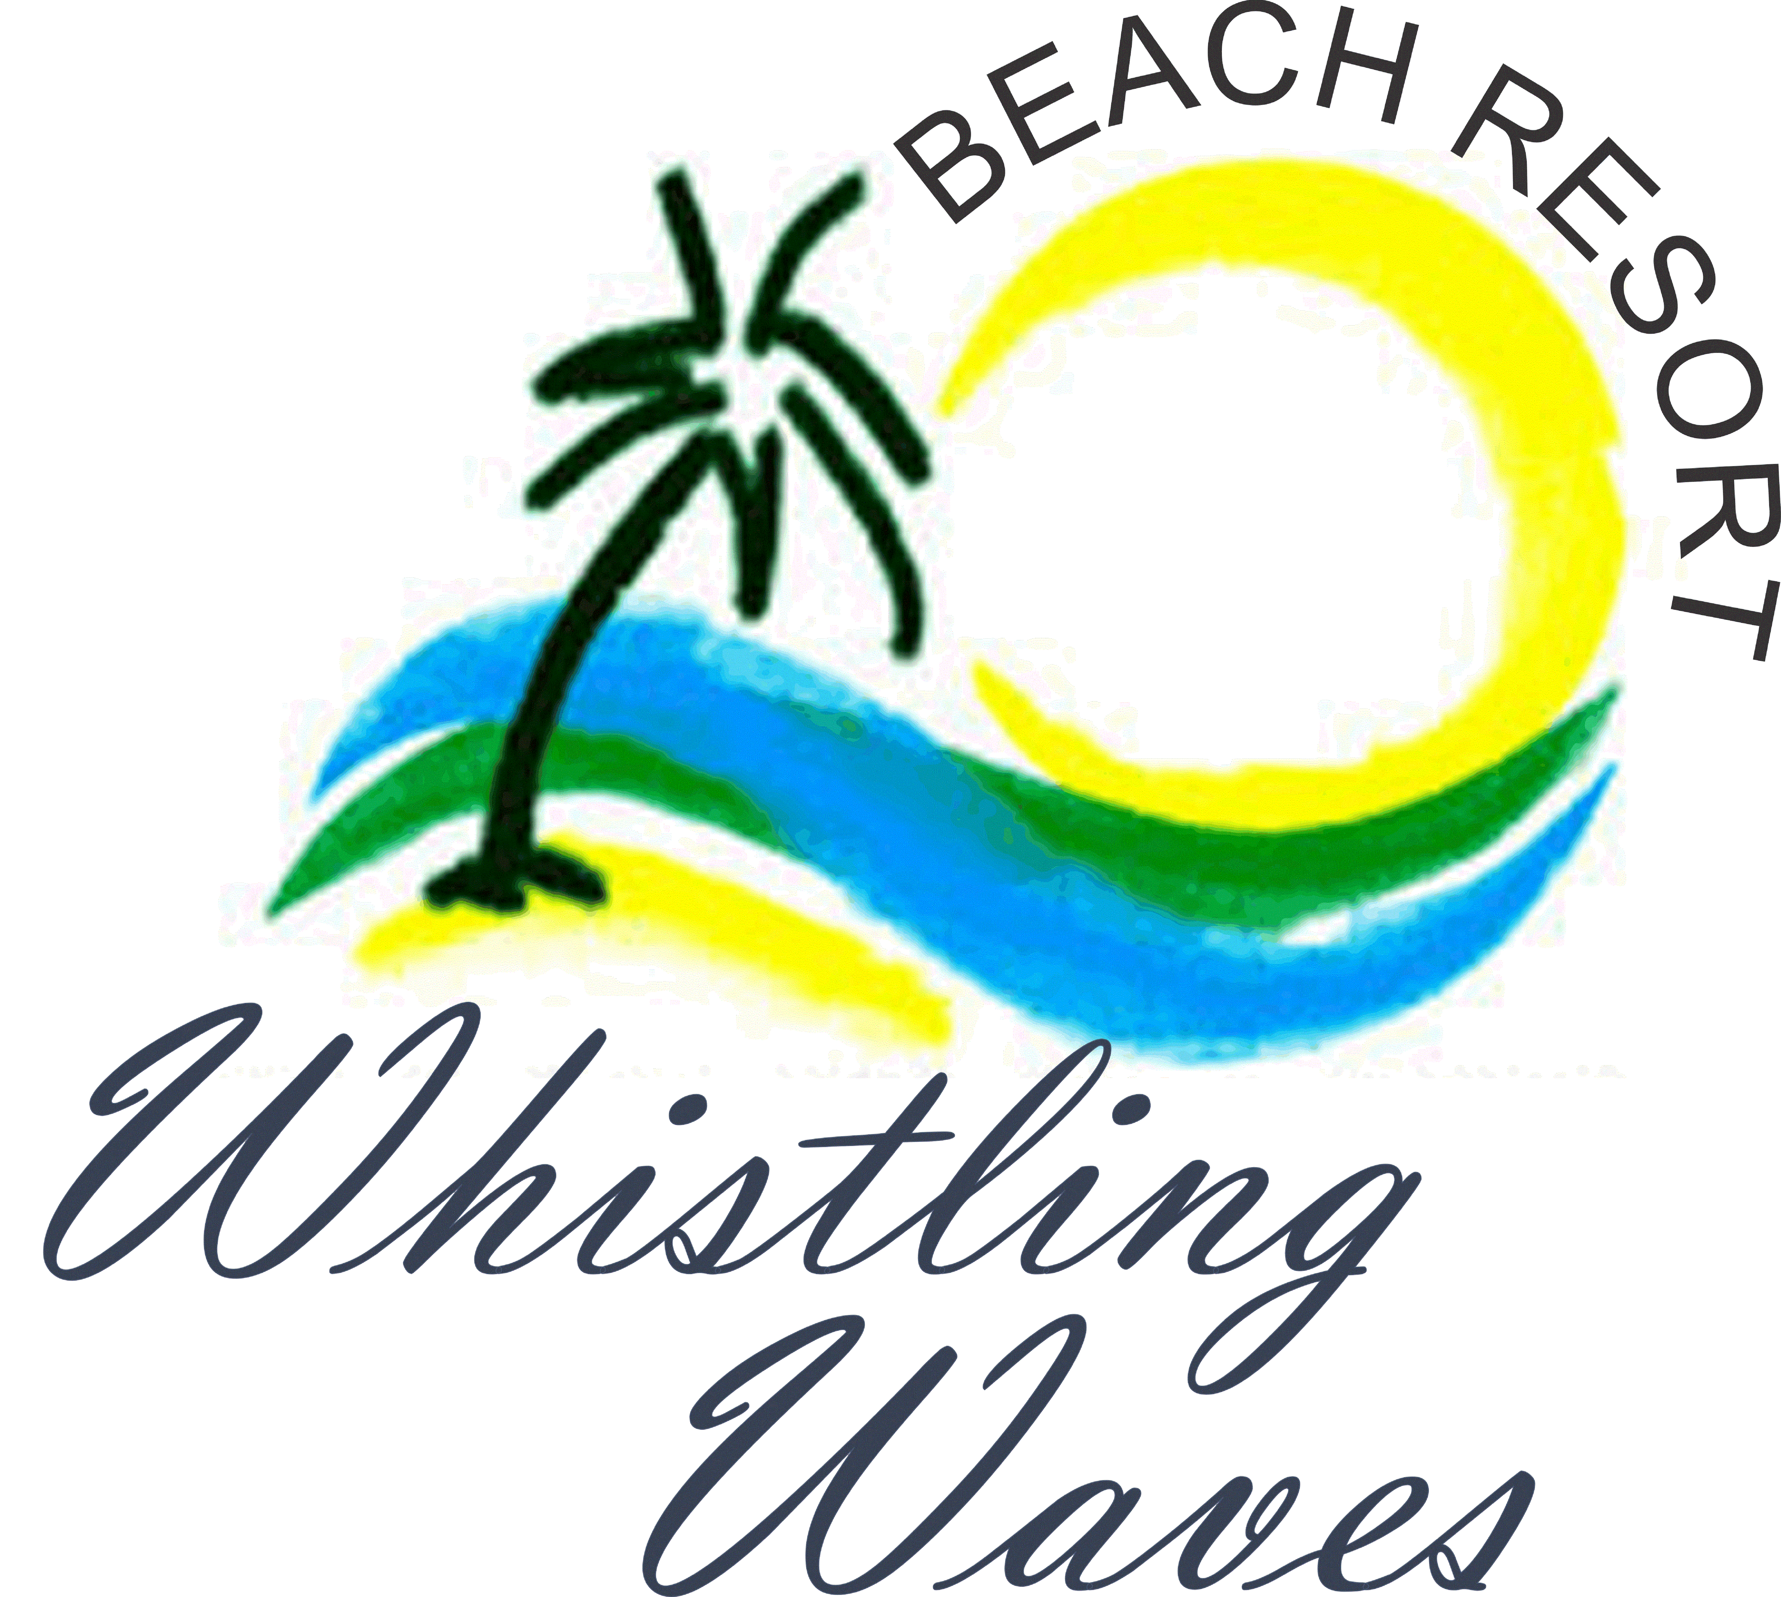 | Whistling Waves Beach Resort  Savane Beach, Anjarle, Dapoli  Call Us : +91 9881147426 | +91 9130744501  WhistlingWaves.com | info@WhistlingWaves.com

House Rules
- Check In is 12:00 PM & Check Out time is 10:00 AM sharp. Extra charges applicable if otherwise.
- Room cleaning is done between 10 AM to 12 PM and only once a day. Please leave a key at the reception staff if you would like the room cleaned.
- Linen / Bed sheets will be changed only after 2 nights stay. If required otherwise it will be charged for.
- Breakfast timing is from 8:00 AM to 10:00 AM. Lunch from 12:30 PM to 2:30 PM. Dinner from 8:00 PM to10:00 PM. Food order will be taken 3 hours prior to above timing as all our meals are prepared fresh.
- No outside food is allowed. All meals are available.
- Food will not be served in the resort rooms. Food will be served in resort dinning & garden area only.
- No cooking in any form is allowed in the rooms. No cooking appliances allowed in the rooms.
- No washing of clothes is allowed in the room or premises.
- Please switch off all electrical appliances when not in use. Please do not keep water running in the bathroom. Please save energy and water.
- Please do not throw sanitary napkins, shampoo sachets, tissue paper, soap pouches etc. into drains or Western Commode. This will cause all the drainage lines get chocked and also cause an inconvenience to you.
- Please do not shift any furniture in the rooms.
- Any damage or breakage of room items or the property will be charged for additionally. Linen/ bed sheets, towels etc. are meant for your use and keep in the rooms after your use.
- Room key must be deposited at the reception staff at the time of check out. If the room key is lost, then guest will be charged Rs. 300 for the room key.
- Guest is requested to enjoy their stay without disturbing other guest or creating any type of loud noise. Guests are to observe night time peace from 11.00 PM to 8.00 AM, i.e. they are not to disturb the other guests accommodated in the Resort.
- Each room is for 2 persons. Extra charges per person is applicable for adult and children above minimum age group and will be given extra mattress / floor bed as required at extra cost.
- Drivers will be charged additionally if they use staff accommodation.
- Electrical backup supply like inverter and generator will be available in the case of severe MSEB supply breakdown. Generator will be available from 2 PM to 4 PM (afternoon time) and 11 PM to 5 AM (night time).
- Please do not litter in or around the premises and nearby area & beach.
- Guests are solely responsible for their valuables. Resort management will not in any way whatsoever, be responsible for the loss of guest's belongings, valuables or any other property.
- Hazardous goods like gas cylinders, cooking stoves, inflammable fuels, firearms, etc. are strictly prohibited by guest in the resort rooms & premises.
- Only registered guest who booked the room are allowed in the resort room & premises. No guest visitors allowed in the room.
- Pets are not allowed in the resort rooms & premises.
- The Resort is only authorized to accommodate properly registered guests. For this purpose, guests are to present their valid government ID proof to the Resort staff. Guest should provide the following information: Full Name, ID number, address, phone number and Email while signing the hotel register book.
- The room tariff is not inclusive of any charges for food and beverages or any other services; these charges will be billed separately.
- Smoking is strictly prohibited in resort rooms due to smoking free rooms. Guest will be solely responsible for bringing & consuming alcoholic drinks / beverage in resort balcony, premises, beach area and resort will not be responsible for the same.
Guest is not allowed to bring or use Hookah and any types of illegal drugs in the resort rooms & premises.
- Guest should check High Tide & Low Tide local timings before swimming (avoid swimming in low tide) in the deep water. Beach is safe for the swimming but please do not go into deep water. Resort management will not in any way whatsoever, be responsible for any accidents occurred or loss of life due to guest own negligence. For security reasons and safety, it is not appropriate to leave children under 10 years of age without adult supervision in the Resort room, Resort premises & on the beach.
- Any complaints or possible suggestions & feedbacks can be submitted in the Feedback Box or can be provided on our contact numbers.

Appreciate if you have read all of the above house rules and it will help us to provide you a wonderful, comfortable & enjoyable stay. Please feel free to call us for any further clarifications.
By Management: Whistling Waves Beach Resort

